F:\Ravini\IJSElogo.png

## 

## BSc (Hons) in computer Science

**GRADUATE DIPLOMA IN SOFTWARE ENGINEERING**

Computer Parts Shop

## STUDENT NAME-Amayuru Indeewara SUBMITTION DATE-(01/10/2021)

## BATCH NO-57

## STUDENT ID-

|  |  |  |  |
| --- | --- | --- | --- |
| **Content** |  | | |
| **No** | **Title** | **Page No** |  |
| 1.0 | Introduction to Business | 2 |  |
| 2.0 | Overview of the proposed solution | 3 |  |
| 3.0 | Advantages of the solution | 3 |  |
| 4.0 | Use Case Diagram | 4 |  |
| 5.0 | Entity Relationship Diagram | 5 |  |

|  |  |  |  |
| --- | --- | --- | --- |
| **List of Tables** |  | |  |
|  |  | |  |
| **No** | **Title** | **Page No** | |
| Table 1.1 | Employment Structure of Company | 14 | |

|  |  |  |  |
| --- | --- | --- | --- |
| **List of Figures** |  | |  |
|  |  | |  |
| **No** | **Title** | **Page No** | |
| Figure 1.1 | Employee Hierarchy | 12 | |

**1) Introduction to business**

Computer parts shop business is one of the most in demand here in Matugama city. The shop has all kind of computer products. The business will be located in matugama.

* Any brand computer
* Motherboard
* Ram card
* VGA card etc.

**History**

This shop is started in 2016. At that time this shop was started on a smaller scale. Firstly this shop doesn’t has many computer parts.

**Employee Hierarchy**

**Owner**

Supplier

Employee

1. **Overview of the proposed solution**

In this computer parts shop they used book record to keep the track of the inventory, but In my software solution they can easily mange their inventory.

**Solution**

First, They need to add the stock to the database. Also they can register the customer details are billy records, Through this it is very easy to check the inventory,

* Most moving parts
* Less moving parts
* Parts need to purchase

This is very user friendly simple solution to grow their business.

1. **Advantages of the solution**

* Add, update, search Customer
* Add, update, search employee
* Add, update, search parts
* Customer order
* View inventory details
* View order details
* View payment details
* Supplier detail

**Use Case Diagram**

<<Include>>

Veryfy Login

l

Error massage

l

Login

<<extend>>>

Most moving part

Inventory Report

Owner

Less moving part

Add Parts

Add Customer

Employee

Customer

Make order

Change order details

Return

Payment

**Entity Relations Diagram**

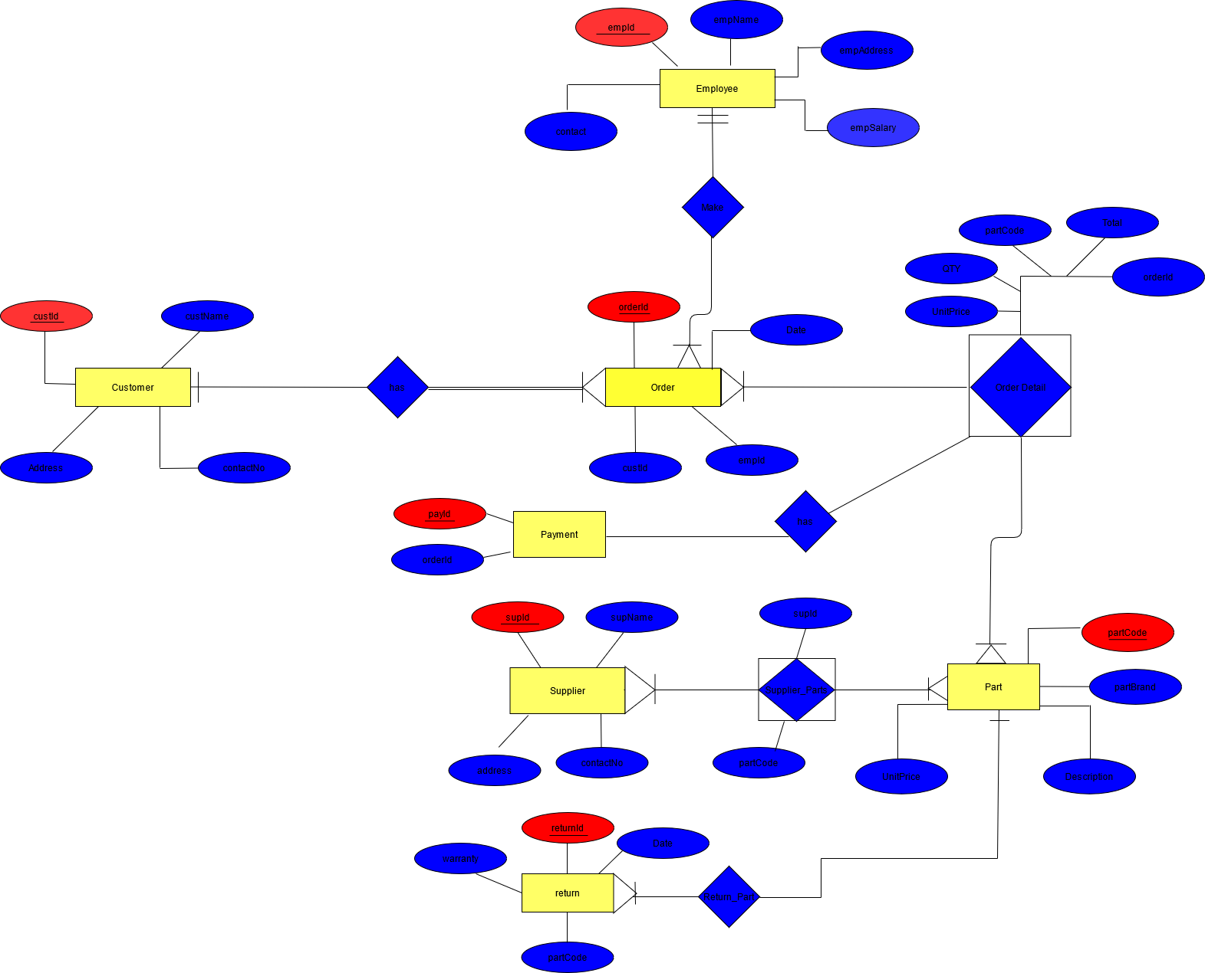

**List of Abbreviation**

Shop owner

Employee

**References**

Armstrong, M. (2009). Armstrong HRM.

Armstrong, M. (2009). Human Resources. In Armstrong Hand Book (pp. 515-539). beyond. (2016). mobile-job-search-apps. Retrieved from [http://about.beyond.com:](http://about.beyond.com:/)

<http://about.beyond.com/infographics/mobile-job-search-apps>

brazen. (2015). 7-innovative-ways-recruiters-attracting-top-talent. Retrieved from [http://www.brazen.com:](http://www.brazen.com/) <http://www.brazen.com/blog/archive/networking/7-innovative-ways- recruiters-attracting-top-talent/>

**Bibliography**

Armstrong, M. (2009). Armstrong HRM.

Armstrong, M. (2009). Human Resources. In Armstrong Hand Book (pp. 515-539). beyond. (2016). mobile-job-search-apps. Retrieved from [http://about.beyond.com:](http://about.beyond.com:/)

<http://about.beyond.com/infographics/mobile-job-search-apps>